Leg Stretches
Stretching is important to help maintain good flexibility, improve muscle tone and to help manage spasticity and muscle spasms. Only do a stretch if you feel steady and comfortable in that position. If your balance is affected you may need to do the stretches in a seated or lying position or hold onto a support while stretching. Remember to stretch both sides of the body. It is okay to feel a little discomfort with a stretch but you should not feel any sharp pain.

Standing Calf Stretch
Start by standing in front of a wall or other sturdy object.
- Step forward with one foot and maintain your toes on both feet to be pointed straight forward.
- Keep the leg behind you with a straight knee during the stretch.
- Lean forward towards the wall and support yourself with your arms as you allow your front knee to bend until a gentle stretch is felt along the back of your leg that is most behind you, with your back heel flat on the floor.
- Hold for 30 seconds
- Repeat five times
- Complete one set per day.

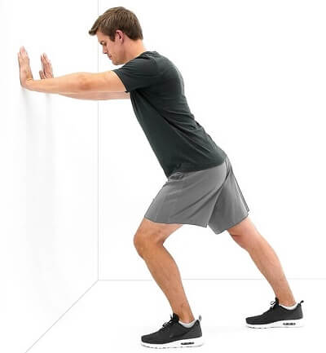

Seated Hamstring Stretch
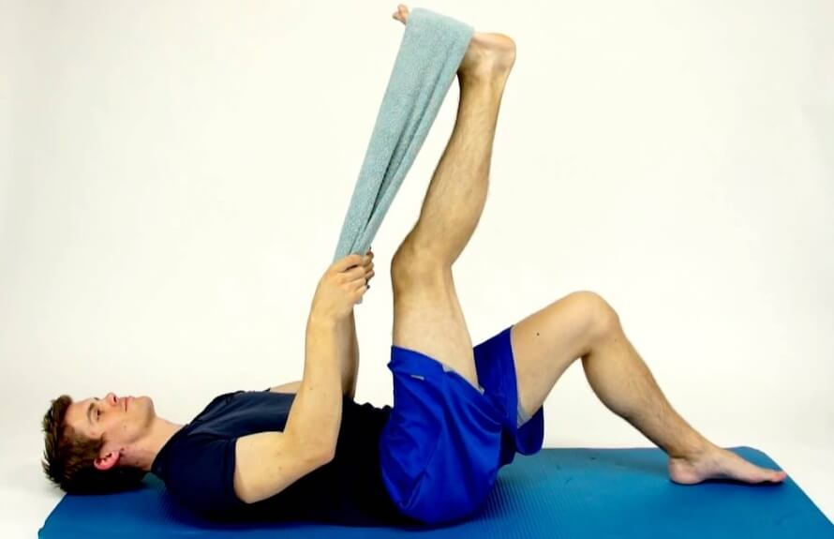
While seated, rest your heel on the floor with your knee straight and gently lean forward until a stretch is felt behind your knee/ thigh.
- Hold for 30 seconds
- Repeat five times
- Complete one set per day.

Hamstring Stretch - Supine
- While lying on your back, raise up your leg and hold the back of your knee.
- Try to straighten the knee and feel a stretch along the back of the thigh.
- Or use a towel or exercise band around the foot as shown, to help to assist the stretch.
- Hold for 30 seconds
- Repeat five times
- Complete one set per day.

Hip Adductor And Groin Stretch
- Lying on your back, with your knees bent, feet together, let the knees fall out to the side until a stretch is felt through the groin and inner thigh.
- Push the knees further apart with your hand to increase the stretch if tolerated.
- Hold for 30 seconds
- Repeat five times
- Complete one set per day.

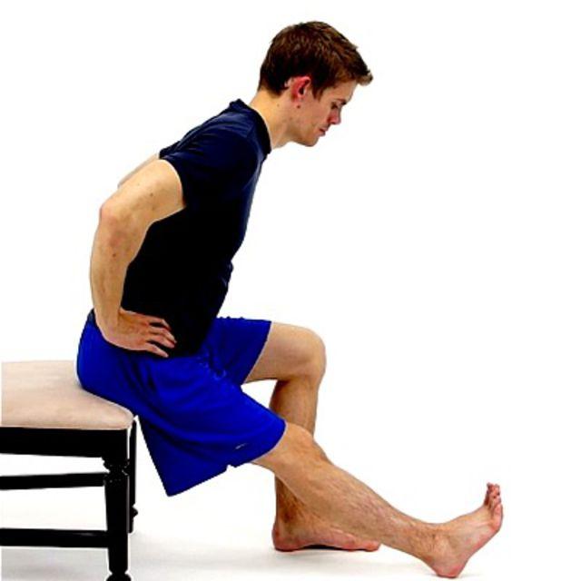

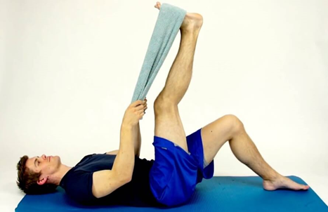

Lower Back/ Hip Stretch
- While lying on your back, hold your knees and gently pull them up towards your chest.
- To ease out the lower back further you can gently rock the knees from side to side.
- Hold for 30 seconds
- Repeat five times
- Complete one set per day.

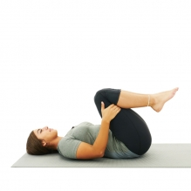

If you need more specific advice and treatment for certain symptoms ask your team in the Multiple Sclerosis (MS) Unit about accessing the physiotherapy service here in the hospital (Tel (01) 416 2503) or ask your GP to refer you to your local primary care physiotherapist.

